**Ideation Phase**

**Define the Problem Statement**

|  |  |
| --- | --- |
| Date | 27 June 2025 |
| Team ID | LTVIP2025TMID33878 |
| Project Name | Revolutionizing Liver Care : Predicting Liver Cirrhosis using Advanced Machine Learning Techniques |
| Maximum Marks |  |

**Customer Problem Statement :**

Patients suffering from liver cirrhosis often receive diagnoses at advanced stages due to the lack of visible symptoms and timely screening. This delay in diagnosis limits treatment options, increases the risk of liver failure, and results in higher hospitalization costs and mortality rates. Healthcare providers lack efficient tools to predict cirrhosis early using routine medical data, making proactive care difficult.

There is a pressing need for an AI-powered solution that can predict liver cirrhosis at an early stage using patient health indicators (e.g., liver function tests, demographic data, medical history). Such a system would help clinicians prioritize high-risk patients, initiate timely interventions, and ultimately improve quality of life while reducing the overall burden on the healthcare system.

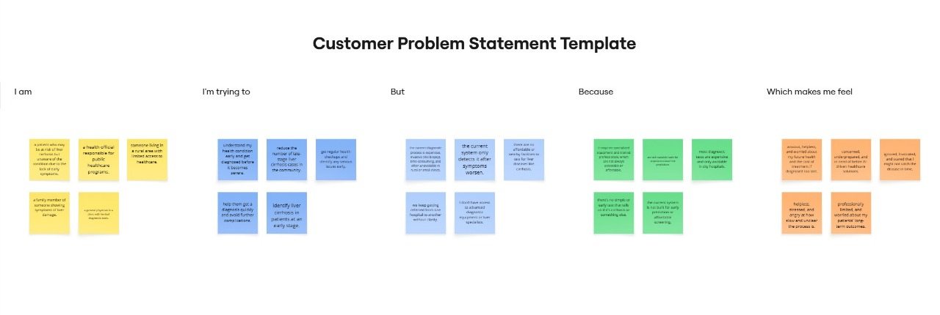

|  |  |  |  |  |  |
| --- | --- | --- | --- | --- | --- |
| **Problem Statement (PS)** | **I am (Customer)** | **I’m trying to** | **But** | **Because** | **Which makes me feel** |
| PS-1 | a patient who may be at risk of liver cirrhosis but unaware of the condition due to the lack of early symptoms. | understand my health condition early and get diagnosed before it becomes severe. | the current diagnostic process is expensive, invasive (like biopsy), time-consuming, and often unavailable in rural or small clinics. | it requires specialized equipment and trained professionals, which are not always accessible or affordable. | anxious, helpless, and worried about my future health and the cost of treatment if diagnosed too late. |
| PS-2 | a health official responsible for public healthcare programs. | reduce the number of late-stage liver cirrhosis cases in the community. | the current system only detects it after symptoms worsen. | we lack scalable tools for population-level risk prediction. | concerned, underprepared, and in need of better AI-driven healthcare solutions. |